Creating Filters
Filters are stored searches. They are useful to quickly switch between common searches. They are also used as a way to set criteria in other modules, such as 'Subscriptions' and 'Reports'.
Filters can be shared, allowing groups to use the same selection criteria. When filters are shared the following caveats apply:
- Only the creator of the filter can modify the filter
- The creator can modify, including delete, the filter even if others are still using it
Once a search/filter has been modified and run an option to 'Save' the search as a filter will appear at the top of the search side-bar (See Illustration 1: A Modified Search).
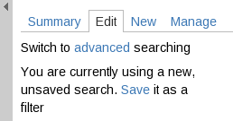
Illustration 1: A Modified Search
If the search is based on an existing filter then a red warning message will appear next to the tabs at the top of the search side-bar to indicate that there are unsaved modifications. (see Illustration 2: The warning for unsaved filters). To save modifications to an existing filter first change the tab to 'Summary' and then use the 'Save' or 'Save as' links. (see Illustration 3: A summary of a modified, previously saved filter)
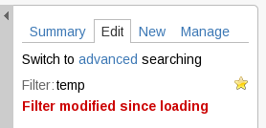
Illustration 2: The warning for unsaved filters
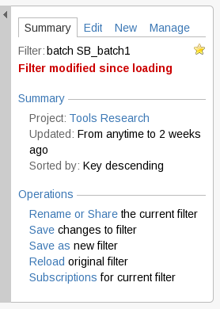
Illustration 3: A summary of a modified, previously saved filter
Clicking 'Save' (in Illustration 1), or the 'Save as' link (in Illustration 3), will bring up the 'Save Current Filter' form (see Illustration 4: The Save Current Filter form). The Filter must be given a 'Name' but a 'Description' is optional.
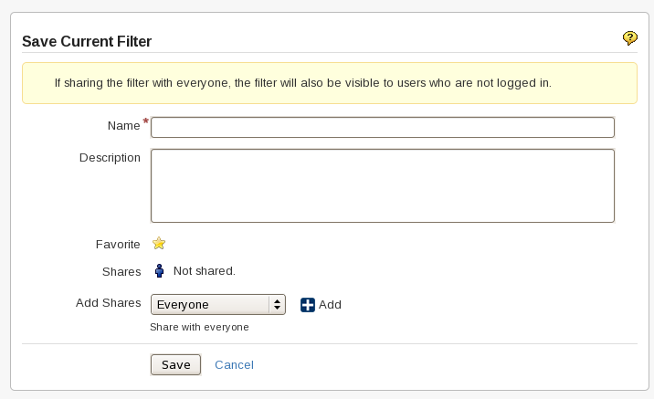
Illustration 4: The Save Current Filter form
Stored filters can be made available to others. Sharing can be done in several ways; to named groups, to users/developers/administrators of a given project or to everyone. Project based shares will probably be the most helpful.

Note: The Share is only added when the button is pressed. Pressing the 'Save' button does not add any un-added Shares.
Favorite filters are added to the 'Issue' drop-down menu (see Illustration 5: Favorite Filters in the Issues drop-down menu). They are also used to group filters on the Manage Filters page. All new filters are automatically set as favorites. To stop a filter being added to this group click on the yellow star next to 'Favorite'. The star should turn gray to indicate that it will not be added as a favorite.
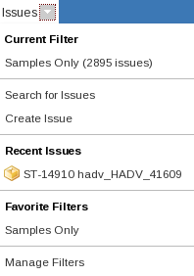
Illustration 5: Favorite Filters in the Issues drop-down menu

